Bran flaked breakfast pancakes

Ingredients
Complexity: Medium
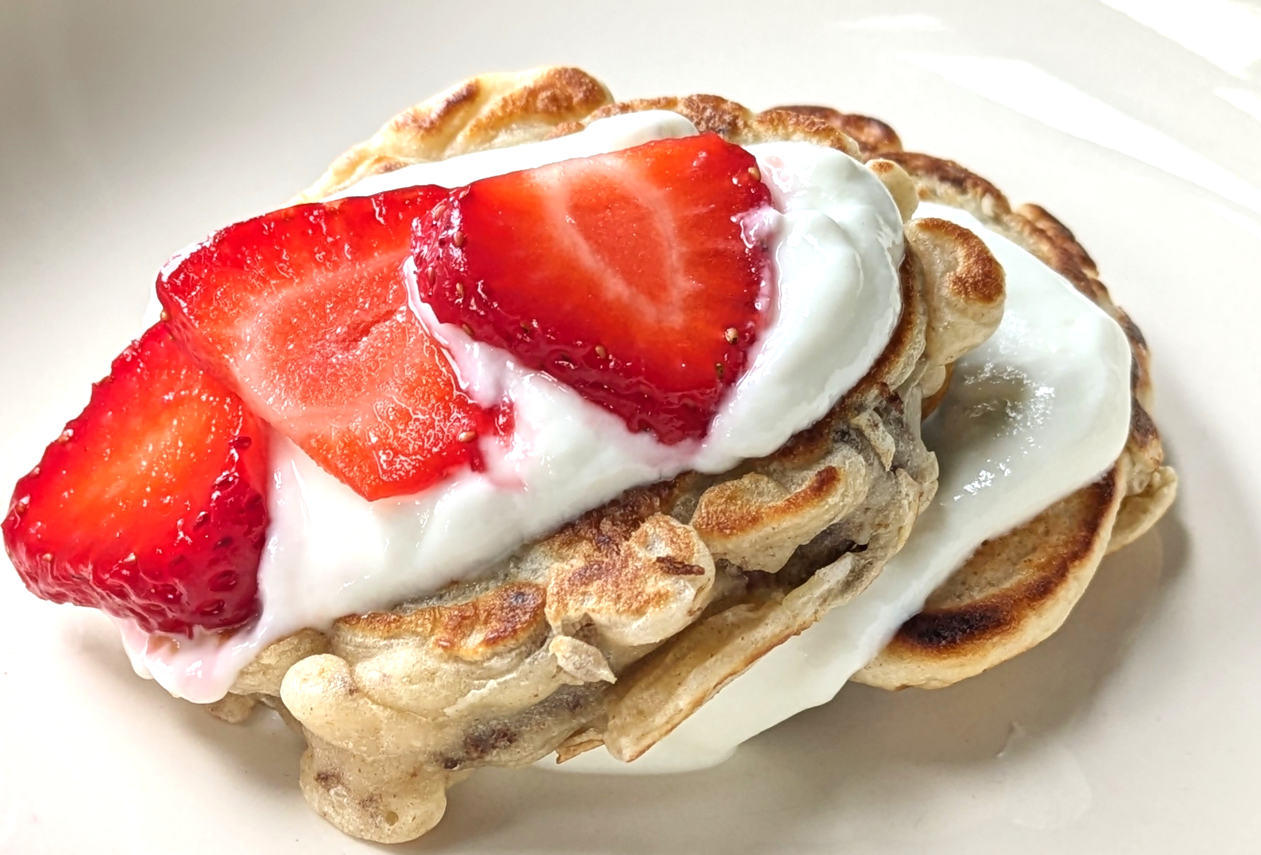
150g self-raising flour
1 medium egg
250ml semi-skimmed milk
30g sultanas
50g bran flakes
Serving suggestion: low fat natural yogurt and fruit
Optional: honey

Equipment
Large bowl, whisk, frying pan, 15ml spoon, spatula

Method
- Place the flour in a large bowl and whisk in the egg.
- Gradually add the milk and whisk to form a batter.
- Stir in the sultanas and bran flakes.
- Heat a little oil in a frying pan and spoon 4 heaped 15ml spoons of the mixture into the pan (to make 4 pancakes).
- Cook gently for 1-2 minutes, turn over and cook for 1 minute until golden.
- Repeat to make 4 more pancakes.
- Serve with low fat natural yogurt and fruit. Optional: drizzle with a little honey.

Top tip
- Try using chopped dried apricots or cranberries instead of sultanas

Food skills
Whisk
Mix, stir & combine
Fry
Portion & divide

