Ratatouille

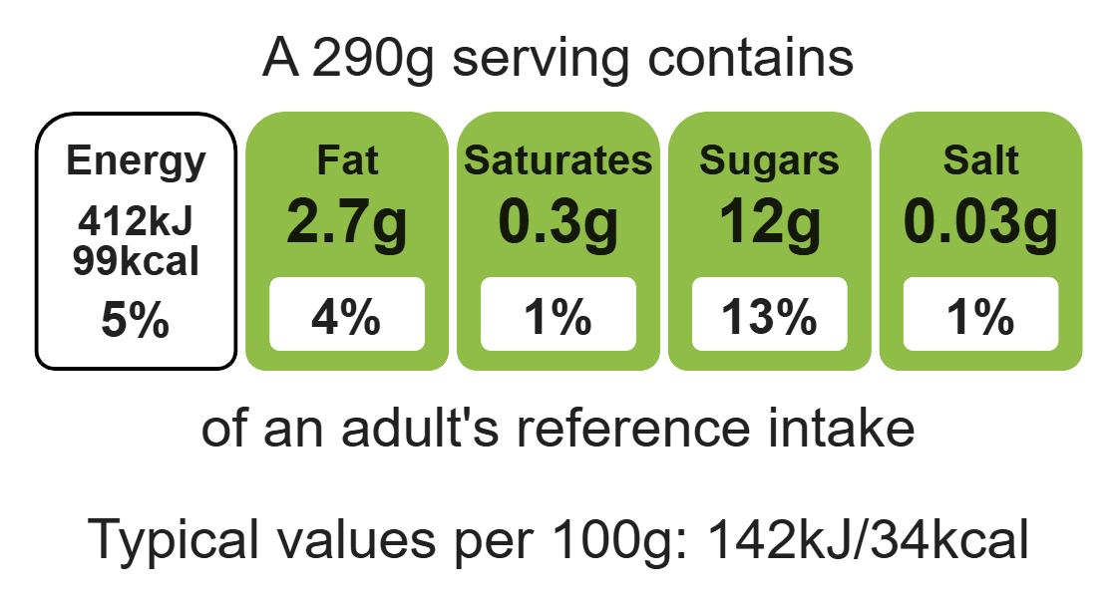
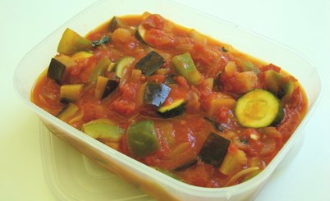

Ingredients (serves 4)

1 onion

1 clove garlic
Complexity: medium

1 aubergine

1 pepper

Equipment

Chopping board

Sharp knife

Garlic press

Saucepan

Measuring spoons

Heat-resistant spoon

Can opener

1 courgette

2 cans chopped tomatoes (800g)

1 x 10ml spoon vegetable oil

1 handful fresh basil

Method
- Prepare the vegetables:
- peel and chop the onion;
- peel and crush the garlic;
- dice the aubergine;
- de-seed and chop the pepper;
- slice the courgette.
- Fry the onion and garlic in the oil for 5 minutes.
- Add the aubergine and fry for a further 5 minutes.
- Add the pepper, courgette and tomatoes.
- Stir-in the torn basil leaves.
- Bring to the boil and then simmer gently, with the lid on the saucepan, for 20-30 minutes.

Top tips
- Turn up the flavour: Use dried herbs if you do not have fresh basil. Try other herbs such as oregano or spices such as chilli or smoke paprika.
- Reduce food waste: Use up any leftover vegetables try adding olives, mushrooms, red onions, peas or beans.
- Serving suggestion: Serve the ratatouille with roasted chicken or grilled fish.

Food skills
Measure, peel, cut, chop, slice, dice and trim, fry and sauté, melt, simmer and boil.

