Sweet mini pancakes
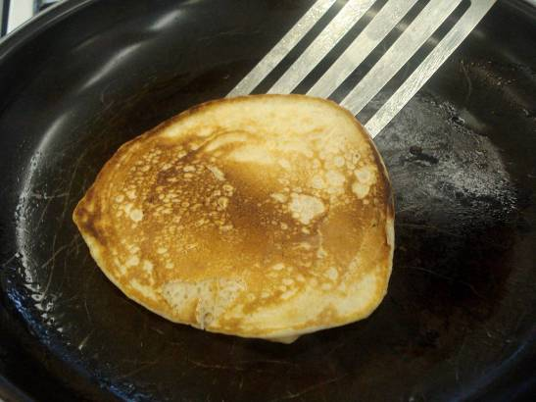
Complexity: low - medium

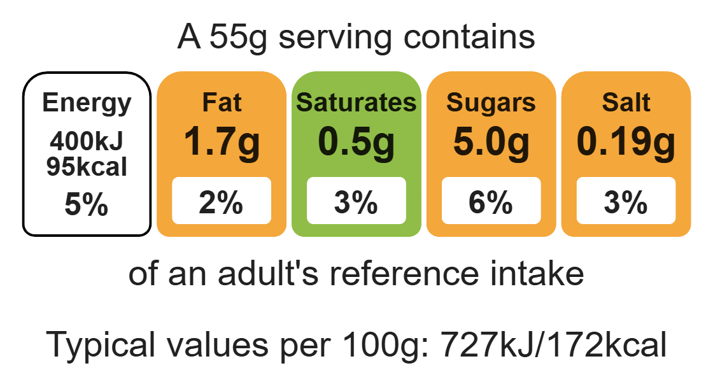

Ingredients (makes 8)

Equipment

Weighing scales

Chopping board

Sharp knife

Sieve

Mixing bowl

Whisk

Measuring jug

Frying pan

Spoon

Fish slice

100g self-raising white flour
25g self-raising wholemeal flour
1 x 15ml caster sugar
180ml skimmed milk
1 egg
100g fruit e.g. blueberries, raspberries, bananas
1 x 5ml oil or spray oil

Method
- Chop the fruit into small pieces or keep whole depending on the size of fruit.
- Sieve the flours into the bowl and add the sugar.
- Whisk the egg and milk into the flour.
- Stir in the fruit.
- Pour into the measuring jug.
- Add oil to the frying pan and heat the frying pan.
- Pour in 2 x15ml spoons of mixture for each pancake.
- Cook until bubbles appear on the surface of the pancake. Turn the pancake using the fish slice.
- Cook the underside of the pancake for one minute or until golden brown.
- Serve.

Top tips
- Reduce food waste: Use up any leftover fruit such as, apricots, berries, peaches, plums or pears. The fruit can be canned, dried or frozen.
- Serving suggestion: Serve with low-fat natural yogurt and a drizzle of honey.
- Transfer to a measuring jug to reduce the spills as the mixture is placed in the frying pan.

Food skills
Weigh, measure, whisk, mix, stir and combine, fry and sauté, cut, chop, slice, dice and trim.

