Muesli pancakes with summer berry compote

Ingredients
Complexity: Medium
125g plain flour
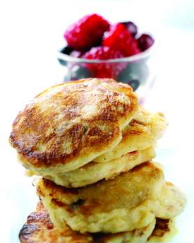
1 x 5ml spoon baking powder
Pinch of salt
75g sugar free muesli
25g caster sugar
2 large eggs separated
284ml carton buttermilk
Vegetable oil

For the summer berry compote:
300g frozen summer berries
Zest and juice of 1 orange

Equipment
Sieve, large bowl, whisk, griddle pan or non-stick frying pan, dessertspoon, pallet knife, small saucepan, zester, juicer.

Method
- Sift the flour, baking powder and salt into a large bowl.
- Stir in the muesli and sugar.
- Make a well in the centre and beat in the egg yolks and buttermilk to make a thick batter, it should have the consistency of thick cream.
- Whisk the egg whites until stiff but not dry and fold into the batter.
- Heat a griddle pan or heavy based non-stick frying pan over a moderate heat.
- Add a tiny drop of oil to the hot pan.
- When the pan is really hot, drop dessertspoons of the batter into the pan.
- Cook for about 2 to 3 minutes, until bubbles start to break on the surface and they are firm enough to flip.
- Flip and cook for 1 to 2 minutes or more, until they feel springy when prodded.
- Transfer to a warm oven while you cook the rest.
- To make the compote, place the summer berries in a small saucepan, add the orange juice and zest and gently heat
Top tips
Try banana and blueberry pancakes by using 125g white flour, 125g wholemeal flour instead of the white flour and muesli mix. Then thinly slice 1 large banana and fold into the batter with the egg whites and cook as above and serve with 300g blueberries.

Food skills
Sift
Mix, stir & combine
Whisk
Fry
Juice
Zest

