Flippin great pancakes

Ingredients
Complexity: Medium-high
75g plain flour
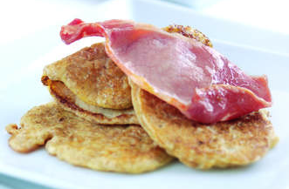
1x 5ml spoon baking powder
25g wheat bran
2 large eggs
200ml semi-skimmed milk
1 x 15ml spoon natural yogurt
Pinch of salt
A little oil for frying
Bacon or ham to serve

Equipment
Sieve, 2 x mixing bowls, spoon, whisk, frying pan, pallet knife or fish slice.

Method
- Sift the flour and baking powder into a mixing bowl, stir in the wheat bran.
- Break the eggs into another bowl and pour in the milk and add the yogurt.
- Whisk together and add the salt.
- Pour quarter of the liquid into the flour and mix with a whisk, pour in a little more and continue mixing until all the liquid has been used to form a smooth batter.
- Heat a small amount of oil in a pan over a medium heat.
- Spoon in a large tablespoon of batter to make 4 small round pancakes.
- Cook until little holes appear on the surface.
- Carefully flip them over using a pallet knife or fish slice.
- Cook for about 1 to 2 minutes and remove from the pan.
- Repeat until all the batter is used up.

Top tips
Serve topped with bacon or ham.

Food skills
Sift
Mix, stir & combine
Whisk
Fry
Portion

