Pork burritos
Complexity: Medium

Ingredients
1 carrot
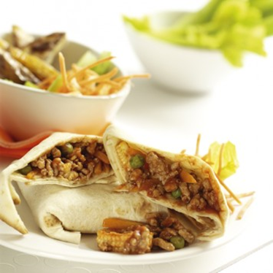
1 tomato
25g hard cheese, e.g. Cheddar
200g lean minced pork
25g frozen peas
50g baby sweetcorn
1 x 10ml spoon Cajun seasoning
3 x 15ml tomato ketchup
4 x 15ml spoon fromage frais
2 flour tortillas or wraps

Equipment
Peeler, vegetable knife, chopping board, weighing scales, grater, non-stick frying pan, mixing spoon, measuring spoons, table knife, 2 serving plates.

Method
- Prepare the ingredients:
  - peel and chop the carrot into thin strips;
  - dice the tomato;
  - grate the cheese.
- Dry fry the lean pork mince in a non-stick frying pan until brown.
- Add the carrots, frozen peas and baby sweetcorn and cook for a further 3-4 minutes.
- Stir in the Cajun seasoning and tomato ketchup.
- Mix well and cook for 2-3 minutes.
- Spread half of the fromage frais over one side of each flour tortilla.
- Place the mince mixture on top of each tortilla.
- Sprinkle half the tomato and cheese on top.
- Fold up the bottom and roll up each tortilla tightly.

Top tips
- Serve with a crunchy lettuce, carrot and cabbage salad and baked potato wedges.
- Try adding different vegetables to the mince, such as grated courgette or sliced mushrooms.

Food skills
- Weigh.
- Measure.
- Peel.
- Chop and dice.
- Grate.
- Fry.
- Stir and mix.
- Spread.
- Shape.

