Savoury pancakes

Ingredients
Complexity: medium
100g white plain flour
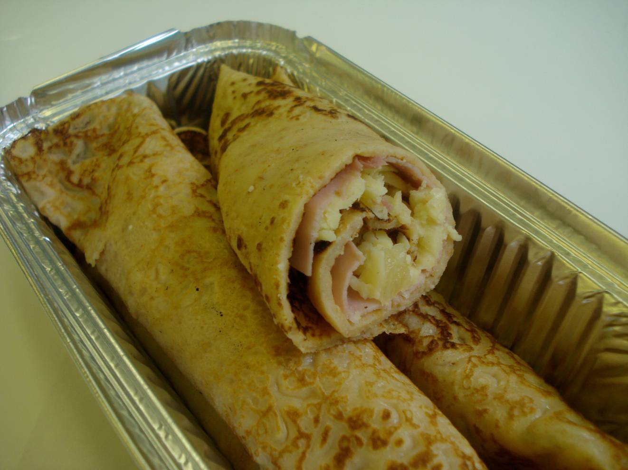
25g wholemeal plain flour
2 eggs (medium)
275 ml semi skimmed milk
Pinch paprika powder
Spray oil for frying
6-8 slices of ham
60g canned pineapple pieces
60g cheddar cheese

Equipment
Weighing scales, grater, chopping board, sieve, mixing bowl, small bowl, fork, wooden spoon, measuring jug, frying pan, 15ml spoon, fish slice, and large metal spoon.

Method
- Grate the cheese.
- Sift the flours and paprika into the mixing bowl.
- Break the eggs into the separate bowl and beat with the fork.
- Make a well in the flour and add the eggs mixing with the wooden spoon.
- Gradually add the milk, mixing well to remove any lumps.
- Pour the mixture into the measuring jug.
- Add a little spray oil to a frying pan on a medium heat.
- Pour three 15ml spoons of the mixture in the centre of the frying pan.
- Cook until bubbles appear on the surface and then turn using the fish slice.
- Cook the underside of the pancake for one minute or until golden brown.
- Grate the cheese and drain the pineapple.
- Roll up pancakes with the ham, pineapple and cheese.

Top tips
- Transfer the pancake batter to a jug or use a ladle to reduce the spills as the mixture is placed into the frying pan.
- Stack the pancakes as you make them between sheets of greaseproof paper on a plate kept in a warm place.
- Different herbs, spices or fillings can be added to the pancake recipe for a different taste.

Food skills
- Weigh.
- Measure.
- Sift.
- Beat.
- Mix, stir and combine.
- Fry.
- Grate.
This recipe is from the original Licence to Cook programme and is provided under the Open Government Licence.

